CPAN133-Operating systems Winter, 2023

**Exercise 9 – Developing Shell Scripts**

**Due: Wednesday March 29, 2023, 11:59 PM**

**For each of the following questions you must make shell scripts on the putty, run it then copy the code as an answer for each of the following questions. Optionally, you can attach screenshot of the output.**

1. Practice arithmetic operations: make a shell script named it as exer9_1.sh and write each of the following lines.

a.Type **let X=10+2*7**

b.Print the content of X

**A: echo $X**

**24**

c.Assign (X+2*4) to the variable Y

**A: let Y=X+2*4**

d.Print the content of Y

**A: echo $Y**

**32**

**#!/bin/bash**

**let X=10+2*7**

**echo $X**

**let Y=$X+2*4**

**echo $Y**

1. Develop a shell script that will prompt the user to enter an integer number, determine if the value is even or odd.

**A:**

**#!/bin/bash**

**read -p "Please enter an integer: " integer**

**if [ "integer % 2" == 0 ]**

**then**

**echo "Your integer is an even number"**

**else**

**echo "Your integer is an odd number"**

**fi**

1. Develop a shell script that will prompt the user to enter either A , B or C :

if A is entered print :“This is A”

if B is entered print :“This is B”

if C is entered print :“This is C”

for any other characters it will print : “You entered a wrong character!”

**A: #!/bash/bin**

**read -p "Enter A, B, or C (in caps) " letter**

**case $letter in**

**"A") echo "This is A";;**

**"B") echo "This is B";;**

**"C") echo "This is C";;**

**\*) echo "You did not enter A, B, or C";**

**esac**

1. Develop a shell script to add two integer numbers and show the result by Considering the following steps:
2. Prompt the user to enter 2 integer numbers between the range of 10 and 20 (inclusive)
3. If the numbers are not in the range it will keep asking “Numbers should be in the range of 10 to 20! Try again:” until a valid rang of numbers are entered.
4. Then the valid 2 integer numbers will be added and it will print “The sum of num1 and num2 is sum” (replace num1, num2 and sum as the value of the variables)
5. Your should check your program with the following sample inputs: (you should attach the screenshot of the output)

x`x`Enter 2 numbers in the range of 10 to 20: 5 19

Number should be in the range of 10 to 20! Try again: 3 12

Number should be in the range of 10 to 20! Try again: 12 9

Number should be in the range of 10 to 20! Try again: 7 12

Number should be in the range of 10 to 20! Try again: 12 15

The sum of 12 and 15 is: 27

**A:**

**a)#!/bin/bash**

**read -p "Enter 2 numbers in the range of 10 to 20: " num1 num2**

**while [ "$num1" -le 10 ] || [ "$num1" -ge 20 ] || [ "$num2" -le 10 ] || [ "$num2" -ge 20 ]**

**do**

**read -p "Number should be in the range of 10 to 20! Try again: " num1 num2**

**done**

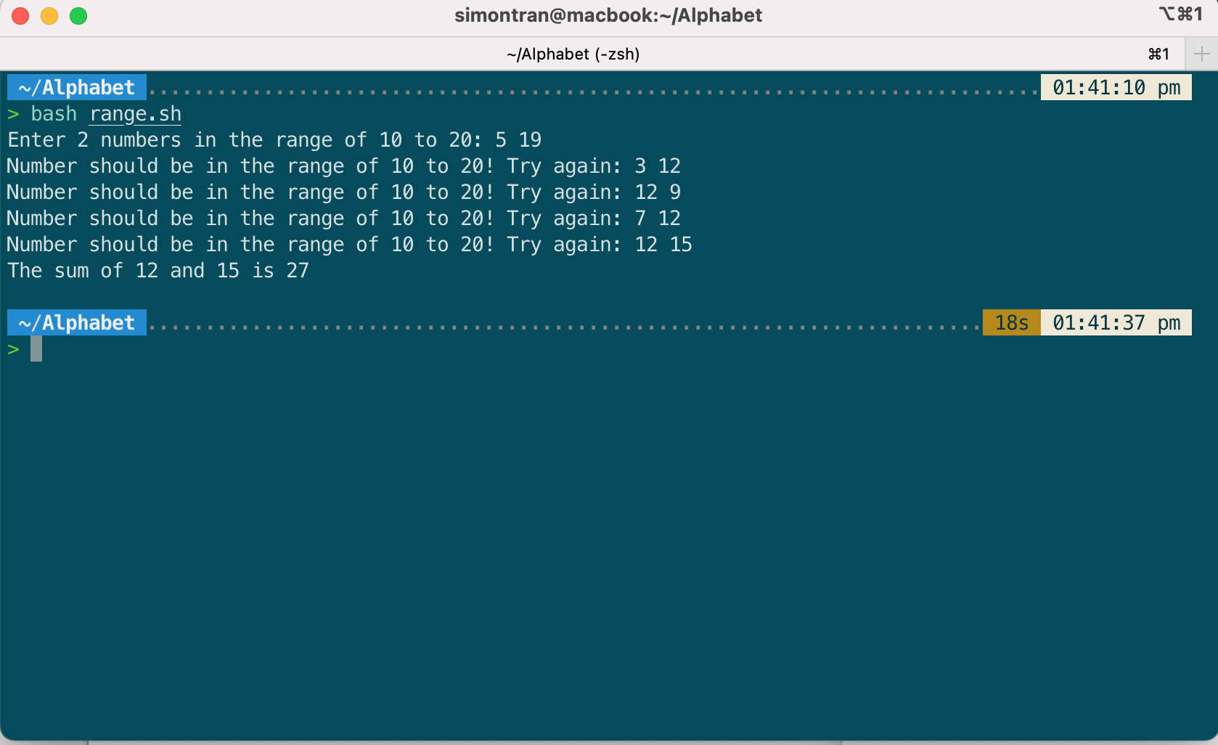**echo "The sum of $num1 and $num2 is" $(($num1+$num2))**